LABORATORY OBSERVATION/RECORD
Course: Full Stack Web Development
Course Code: 23CM4121
Task No.: 3
Student Name: EMANDI HARI CHARAN
Roll No.: A24126552080
Date:

OBSERVATION TASK 3: DYNAMIC TO-DO LIST APPLICATION USING JAVASCRIPT DOM

Task Description & Requirements
Task Requirement:
Develop an interactive To-Do List web application using HTML5, CSS3, and JavaScript DOM manipulation. The application allows users to enter tasks into an input field, dynamically create new list items (document.createElement), mark items as completed (toggling CSS strikethrough classes), remove items from the DOM (li.remove()), and automatically toggle the visibility of an empty list message.

Source Code
index.html
<!DOCTYPE html>
<html>
<head>
<title>My To-Do List</title>
<style>
body {
font-family: Arial;
background-color: #f2f4f8;
text-align: center;
margin-top: 50px;
}
h1 {
color: #333333;
}
.input-section {
margin: 20px;
}
input {
padding: 10px;
width: 250px;
border: 1px solid #cccccc;
border-radius: 5px;
}
#addTask {
padding: 10px 15px;
background-color: #4CAF50;
color: white;
border: none;
border-radius: 5px;
cursor: pointer;
}
#addTask:hover {
background-color: #45a049;
}
#emptyMessage {
color: #777777;
}
ul {
list-style-type: none;
padding: 0;
}
li {
background-color: white;
margin: 10px auto;
padding: 10px;
width: 400px;
border-radius: 5px;
box-shadow: 0 2px 5px #cccccc;
}
.complete {
margin-left: 15px;
padding: 5px 10px;
background-color: #2196F3;
color: white;
border: none;
border-radius: 4px;
cursor: pointer;
}
.delete {
margin-left: 5px;
padding: 5px 10px;
background-color: #f44336;
color: white;
border: none;
border-radius: 4px;
cursor: pointer;
}
.complete:hover {
background-color: #1976D2;
}
.delete:hover {
background-color: #d32f2f;
}
/* Completed task */
.completed {
text-decoration: line-through;
color: #888888;
}
</style>
</head>
<body>
<h1>My To-Do List</h1>
<div class="input-section">
<input type="text" id="taskInput" placeholder="Enter a task">
<button id="addTask">Add Task</button>
</div>
<p id="emptyMessage">No tasks available.</p>
<ul id="taskList"></ul>
<script src="Script.js"></script>
</body>
</html>

Script.js
let taskInput = document.getElementById("taskInput");
let addTask = document.getElementById("addTask");
let taskList = document.getElementById("taskList");
let emptyMessage = document.getElementById("emptyMessage");
addTask.onclick = function () {
let task = taskInput.value;
if (task == "") {
alert("Please enter a task");
return;
}
// Create task
let li = document.createElement("li");
li.innerHTML = task;
// Create Complete button
let completeButton = document.createElement("button");
completeButton.innerHTML = "Complete";
completeButton.className = "complete";
// Complete task
completeButton.onclick = function () {
li.classList.toggle("completed");
};
// Create Delete button
let deleteButton = document.createElement("button");
deleteButton.innerHTML = "Delete";
deleteButton.className = "delete";
// Delete task
deleteButton.onclick = function () {
li.remove();
if (taskList.children.length == 0) {
emptyMessage.style.display = "block";
}
};
li.appendChild(completeButton);
li.appendChild(deleteButton);
taskList.appendChild(li);
taskInput.value = "";
emptyMessage.style.display = "none";
};

Actual Output Screenshots
Output 1: Initial Empty Task List View ('No tasks available')
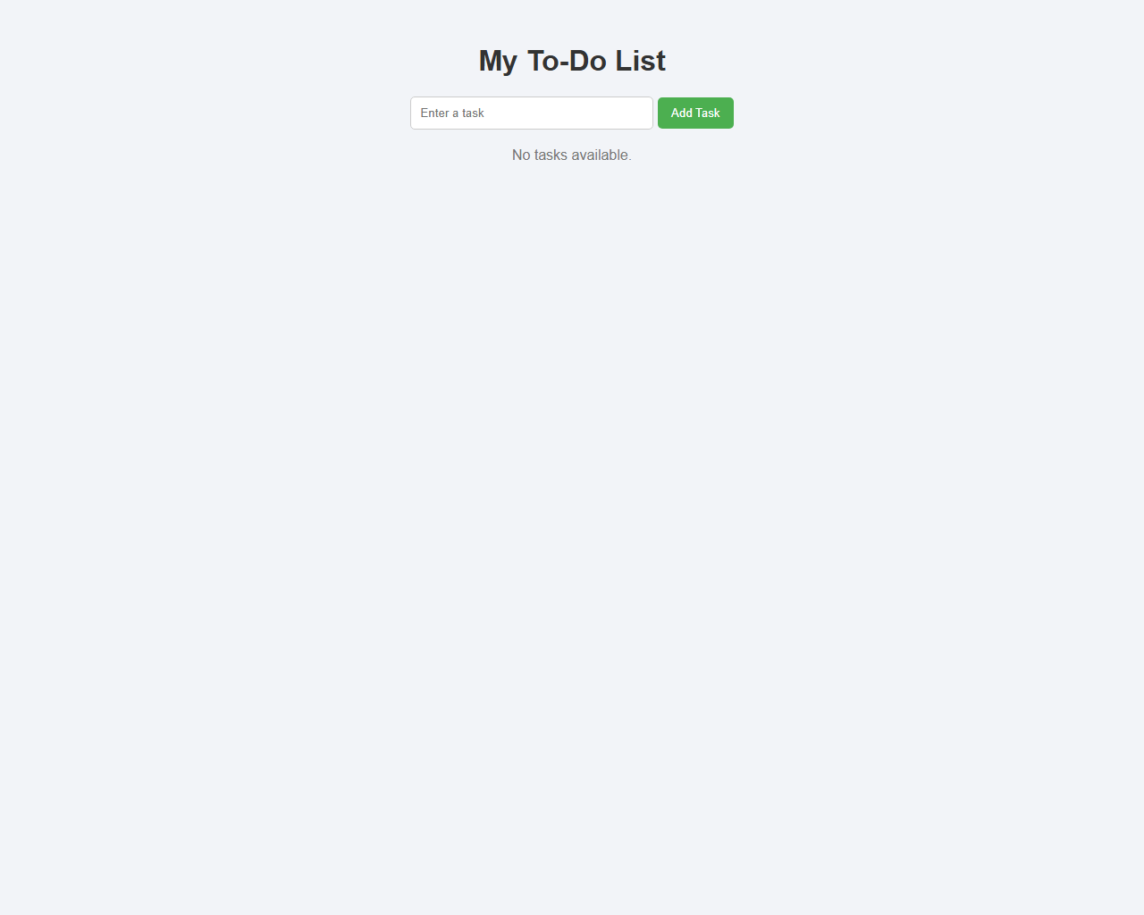
Output 2: Interactive To-Do List Execution View (Adding, Completing & Deleting Tasks)
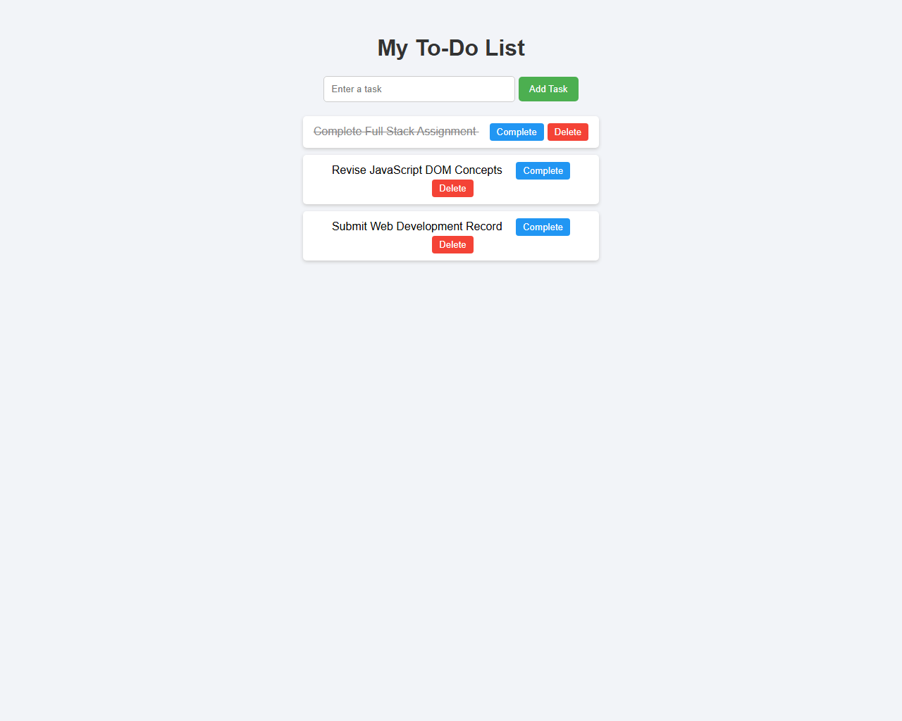

Result / Conclusion
Result: Observation Task 3 was executed and verified successfully. The dynamic To-Do List application accurately handles task entry validation, dynamic DOM element creation (<li> and <button>), class toggling (.completed strikethrough), element removal, and empty state message toggling.

